Image Classification of Animals
Using CNNs and PCA

Jan McConnell, MSDS
janmcconnell@cityuniversity.edu

DS510 Artificial Intel for Data Sci (Summer 2025-2026)
School of Technology and Computing
City University of Seattle
Seattle, WA 98121

Abstract

This project looks at how well Convolutional Neural Networks (CNNs) can classify images of animals and examines whether applying Principal Component Analysis (PCA) improves the results, using a small selection from the High-Resolution Cat-Dog-Bird Image Dataset, with 150 grayscale images in total, divided evenly between cats, dogs, and birds. The goal is to compare classification accuracy, training time, and loss between models trained on raw images and those preprocessed with PCA. The project highlights how dimensionality reduction can influence both efficiency and generalization in small-scale image classification tasks. Performance metrics and visualizations, including confusion matrices and loss curves will support findings.

Keywords: Convolutional Neural Networks, Image Classification, Principal Component Analysis, Dimensionality Reduction, Animal Recognition, Python

1. INTRODUCTION

Image classification plays a central role in many computer vision and machine learning tasks, from identifying medical conditions in radiology scans to tagging objects in social media photos. It has become increasingly important as organizations collect and store large volumes of visual data. In this project, the goal is to classify images of three types of animals, cats, dogs, and birds, using a small grayscale dataset. Although the classification task may appear simple, it presents useful challenges related to input quality, data size, and model generalization.

The project uses Convolutional Neural Networks (CNNs) to perform the classification. CNNs are widely used in image analysis because they are good at detecting patterns in visual data. Unlike traditional machine learning models, CNNs do not rely on manual feature extraction. Instead, they learn directly from raw pixel values. As Rothman (2020, Chapter 9) explains, CNNs are able to capture spatial hierarchies by applying convolutional filters that detect edges, shapes, and textures, which are important for recognizing different objects.

In addition to using CNNs, the project explores how Principal Component Analysis (PCA) affects the model’s performance. PCA is a technique for reducing the number of input features in a dataset. It works by identifying the directions (or components) that capture the most variance in the data. By keeping only the most important components, PCA can compress the input and potentially remove noise. In theory, this could help models train faster and avoid overfitting. However, there is also a risk of losing useful information, especially in image data, where even minor visual details can affect classification outcomes.

To test the impact of PCA, two models are trained: one on the original images and one on the PCA-transformed images. Both use the same CNN architecture and training process. The models are evaluated based on training accuracy, validation accuracy, loss, and how well they generalize to new data. The goal is to determine whether dimensionality reduction improves performance or whether it discards valuable information needed for accurate classification.

This comparison can offer insight into the trade-offs between training efficiency and classification accuracy, especially when working with small datasets. The results may help inform decisions about preprocessing steps in future image classification projects.

2. LITERATURE REVIEW

Convolutional Neural Networks (CNNs) are commonly used in image classification tasks because they can learn patterns directly from pixel data. Unlike traditional methods that rely on manual feature extraction, CNNs automatically identify simple features such as edges in early layers and more complex structures in deeper layers (Brownlee, 2021). Rothman (2020, Chapter 9) explains that CNNs are particularly well-suited for visual data because they take advantage of the spatial structure in images, allowing the model to learn features based on local patterns.

In addition to being effective, CNNs are also efficient. Their design reuses filters across the image, which reduces the number of trainable parameters and allows the model to train faster. This makes them ideal for tasks where computational resources or dataset sizes are limited (Rothman, 2020, Chapter 9).

Principal Component Analysis (PCA) is another tool often used in machine learning workflows. It reduces the dimensionality of input data by transforming it into a new set of uncorrelated variables, called principal components, that retain the most important information. According to Scikit-learn (n.d.), PCA is helpful for simplifying data before training, especially when working with high-dimensional datasets. PCA has been applied successfully in image classification tasks to improve training efficiency without significantly impacting model performance (Sharma, 2019).

GeeksforGeeks (2025) describes PCA as a valuable technique for focusing the learning process on the most relevant features by filtering out noise and redundancy which can reduce training time and help models generalize better. By compressing the input space, PCA makes it easier for algorithms like CNNs to detect meaningful patterns with fewer computations.

While CNNs and PCA are often used separately, combining them can be beneficial, especially in cases where training data is limited. This project applies both methods together to explore whether preprocessing with PCA enhances model performance. Rothman (2020, Chapter 14) encourages practical experimentation with AI tools, and this work follows that approach by evaluating the impact of PCA on a CNN trained to classify grayscale images of cats, dogs, and birds.

3. METHODOLOGY

This project explores image classification using a CNN to distinguish between grayscale images of cats, dogs, and birds. Twp separate datasets were prepared and analyzed: one consisting of the original images, and another reduced using PCA.

3.1 Data Preprocessing
The images were first resized to 64×64 pixels and converted to grayscale to ensure uniformity. For the PCA-based dataset, each image was flattened into a 1D array and normalized. PCA was applied to reduce dimensionality while preserving 95% of the variance, significantly lowering the number of input features for the model. The 64×64-pixel format was retained and only normalized the pixel values.
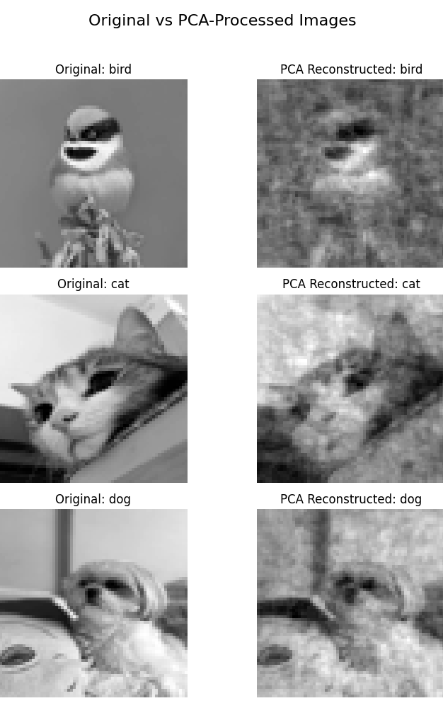
Figure 1: Original vs PCA-processed images.
To visually assess the impact of dimensionality reduction, a sample image from each class was reconstructed using the PCA-reduced features. As shown in Figure 1, the PCA reconstruction preserves the overall structure and orientation of each animal but loses fine details and texture. This visual loss of information illustrates one of the trade-offs of using PCA in image classification.

Both datasets were split into 80% training and 20% testing sets while keeping a similar number of cats, dogs, and birds in each set. One-hot encoding was used to convert the labels into categorical format, appropriate for multi-class classification.

3.2 Model Design and Training
A simple CNN model was built using TensorFlow and Keras. The architecture consisted of two convolutional layers with max-pooling, followed by a flattening layer and two dense layers. The Adam optimizer and categorical crossentropy loss function was used, each model was trained for 10 epochs with a batch size of 8, and training/validation accuracy was plotted. Confusion matrices were also generated to analyze performance across classes.

Accuracy metrics and visual outputs were compared between the PCA-reduced and original datasets to evaluate trade-offs in complexity, training time, and overall model performance. These comparisons helped assess the impact of dimensionality reduction on learning efficiency and generalization.

4. RESULTS

To reduce the dimensionality of the 64×64 grayscale images, PCA was applied to retain 95% of the variance, resulting in 86 principal components out of the original 4,096. This transformation significantly reduced the number of input features which enabled faster training without requiring changes to the CNN architecture.

Figure 1 provides a side-by-side comparison of original and PCA-reconstructed images for a bird, a cat, and a dog. While the PCA images preserve overall shape and orientation, they clearly lose finer details such as texture and contrast, which may affect classification accuracy.

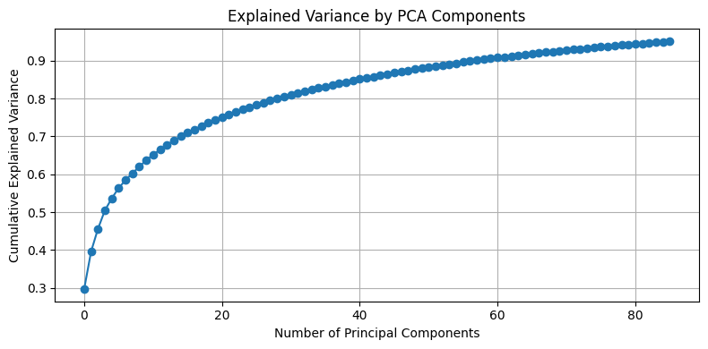
Figure 2: Explained variance by PCA component.
Figure 2 shows that 95% of the variance is retained after the first 86 components, supporting PCA’s ability to compress data while preserving key information.

The CNN trained on PCA-reduced images achieved a final training accuracy of 99.2% after 10 epochs. However, its validation and test accuracies were substantially lower at 36.7%. This wide discrepancy between training and validation accuracy indicates strong overfitting.

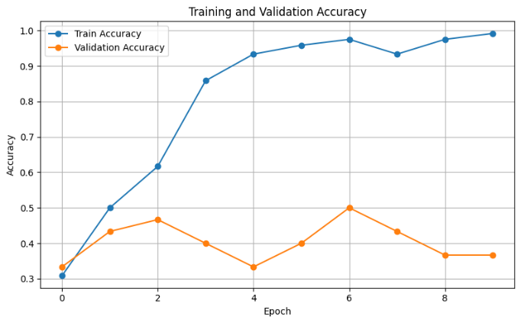
Figure 3: Training and validation accuracy for the PCA-reduced input.
Figure 3 illustrates this overfitting, while the training accuracy curve steadily improves, the validation curve remains flat or unstable across epochs.

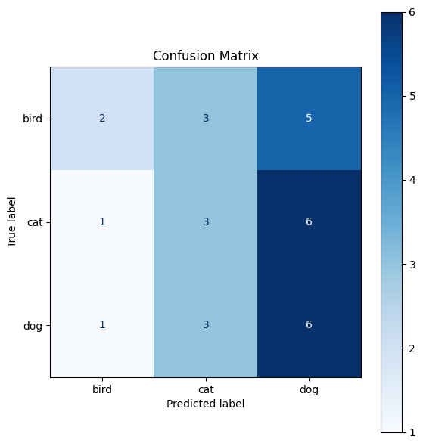
Figure 4: Confusion matrix for the PCA-reduced model.
Figure 4 displays the confusion matrix for the PCA model. Most predictions were skewed toward the dog class, with many bird and cat images misclassified as dogs. This suggests the PCA process may have distorted class-distinguishing features.

In contrast, the CNN trained on the original image data reached a lower training accuracy of 97.5%, but with a modestly improved falidaton accuract of 40.0%, indicating better generalization than the PCA-based model.

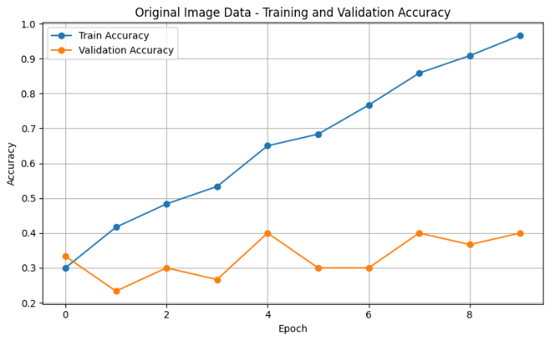
Figure 5: Training and validation accuracy for the original image input.
Figure 5 shows the training and validation accuracy for the model trained on original inputs. While overfitting is still present, the validation performance is slightly more stable.
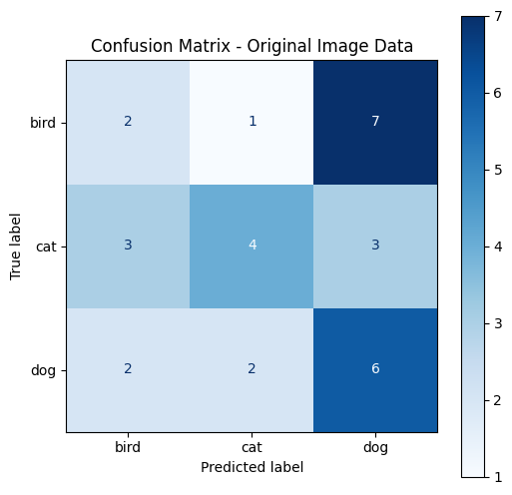
Figure 6: Confusion matrix for the original-image model.
Figure 6 presents the confusion matrix for the original-image model. Predictions are more evenly distributed across all classes, although the bird class was frequently misclassified as dog.

Overall, the PCA-reduced model trained faster and achieved near-perfect accuracy on training data but failed to generalize well. The original-image model performed slightly better on unseen data, though both models showed signs of overfitting. These findings suggest that while PCA is effective at compressing input data, it may remove critical visual cues required for accurate image classification in small datasets.

Metric | PCA-Based  Model | Original  Image  Model
Number of Input Features | 86 | 4,096
Training Accuracy | 99.2% | 97.5%
Validation Accuracy | 36.7% | 40.0%
Test Accuracy | 36.7% | 40.0%
Overfitting Observed | Yes | Yes
Class Distribution (CM) | Skewed to dog | More balanced
Training Time | Lower | Higher
Table 1: Model Performance Comparison
As shown in Table 1, the PCA-based model trained faster and achieved higher training accuracy but performed worse on validation and test data. The confusion matrix revealed a strong bias toward predicting the dog class, indicating poor generalization. In contrast, the original image model required more computation but produced more consistent predictions across all classes and slightly higher test accuracy. These results underscore the trade-off between training efficiency and classification reliability when using dimensionality reduction on small image datasets.

5. DISCUSSION

Using PCA to reduce the number of input features led to faster training and very high accuracy on the training set. However, that did not carry over to new data. The PCA-based model showed clear signs of overfitting. Validation and test accuracy stayed low, and the confusion matrix revealed that it had trouble telling cats and birds apart from dogs. This makes sense, given that PCA discards information that may be helpful for fine distinctions. In grayscale animal images, those distinctions often rely on subtle differences like fur texture, beak shape, or the position of the ears, details that are easy to lose in compression.

In contrast, the model trained on the original images learned more slowly but made better predictions on unseen data. It still overfit, but not as severely. Its confusion matrix was more balanced, and the validation accuracy was slightly higher and more stable. This suggests that keeping the full image gave the model more to work with when learning how to separate the classes.

These findings suggest that PCA is not always helpful, especially with small image datasets. Even though it improved efficiency, it may have removed just enough visual detail to limit model performance. That said, PCA is still a useful tool when used under the right conditions. If the dataset were larger or more redundant, or if we had used additional techniques like dropout or data augmentation, PCA might have had better results.

For this project, though, the trade-off was clear: the original images helped the model generalize better, even if the training took a little longer. This points to a larger lesson, simplifying input is not always worth it if it means the model misses out on the details it needs to make accurate predictions.

6. CONCLUSION

This project set out to answer a specific question: does applying PCA before training a CNN help or hurt image classification on a small dataset? The answer, at least in this case, is that it hurts more than it helps.

The model trained on PCA-reduced images did finish training faster and reached high accuracy during training. But when it came to classifying new data, it did not perform well. Its predictions skewed heavily toward the dog class, and its validation and test scores hovered around 30 percent. Visual inspection of the reconstructed images confirmed that important details were lost in the PCA process.

The model trained on original images did a little better across the board. It took longer to train, but it held up better when tested on new images. It still overfit, but not as badly, and its predictions were more balanced. This suggests that the full spatial information in the original images helped the model recognize class differences more effectively.

While PCA did reduce dimensionality from 4,096 to 86 features while keeping 95 percent of the variance, that last 5 percent may have made a big difference. For small datasets like this one, every pixel counts.

If I were to continue this work, I would try combining PCA with regularization techniques or using a larger dataset. It might also be worth comparing PCA to other dimensionality reduction methods like autoencoders. Overall, the results from this project show that while PCA is a powerful tool, it should be used carefully in image classification tasks where fine details matter.

7. REFERENCES
Brownlee, J. (2021, January 27). A gentle introduction to object recognition with deep learning. Machine Learning Mastery. https://machinelearningmastery.com/object-recognition-with-deep-learning/
GeeksforGeeks. (2025, July 11). Principal Component Analysis (PCA). https://www.geeksforgeeks.org/data-analysis/principal-component-analysis-pca/
Mahmoud, N. (2022). High resolution cat-dog-bird image dataset (13000 images) [Data set]. Kaggle. https://www.kaggle.com/datasets/mahmoudnoor/high-resolution-catdogbird-image-dataset-13000
Rothman, D. (2020). Artificial intelligence by example (2nd ed.). Packt Publishing.
Scikit-learn. (n.d.). Principal Component Analysis (PCA). https://scikit-learn.org/stable/modules/decomposition.html#pca
Sharma, M. (2019, August 15). Guide to Principal Component Analysis. Medium. https://medium.com/analytics-vidhya/guide-to-principal-component-analysis-ab04a8a9c305

